**York City FC and The Wilf Ward Family Trust**

**Inclusive Access Match Day Guidance**

**Getting Your Match Tickets**

All tickets must be booked with the Ticket Office, ideally in advance of the game.

*How do I book match tickets?*

* [Online via the club website](https://yorkcityfootballclub.co.uk/accessibility-tickets/)
* By phone on 01904 950950
* By e-mail at [tickets@yorksmc.co.uk](mailto:tickets@yorksmc.co.uk)
* In person at the Ticket Office at LNER Community Stadium*

*The Ticket Office has a specific accessible serving point for wheelchair and mobility scooter users.

*Are there wheelchair or mobility scooter user spaces?*

The East Stand features a gantry with wheelchair and mobility scooter user spaces between regular seating. This area and seats in higher rows can be accessed via the Hospitality Entrance and lifts for any supporters with mobility issues who have East Stand tickets. Enter via the Hospitality entrance and collect a blue access wristband upon arrival.

The West Stand has an extensive gantry with wheelchair and mobility scooter user spaces between regular seating. This area is situated above the main seating area and is accessed by 2 lifts as soon as you enter.

There is pitch level spaces and seating for wheelchair and mobility scooter users at the East, South, and North Stands, however please note that these are unprotected from the elements and there is nothing between these spaces/seats and the playing area.

*Left: East Stand wheelchair and mobility scooter user spaces*

*Right: West Stand wheelchair and mobility scooter user spaces*

*Are carers eligible for a free ticket?*

Yes, all carers can obtain a free ticket if they are attending the match with a person they provide care for. Please note that carer tickets are also subject to the 80p per ticket booking fee, as are all other ticket categories at the stadium.

*Booking Accessible and Carer Tickets*

Tickets for accessible spaces in the East and West stands are [available to book online through the dedicated Accessible page](https://yorkcityfootballclub.co.uk/accessibility-tickets/). Ambulant disabled tickets can also be purchased with a carer in a more suitable location depending on individual needs.

* [**Book HOME supporter accesible tickets here.**](https://yorkcityfootballclub.co.uk/accessibility-tickets/)
* [**Book AWAY supporter accesible tickets here.**](https://yorkcityfootballclub.co.uk/accessibility-tickets-away-supporters/)

[Using the interactive map](https://yorkcityfootballclub.co.uk/accessibility-tickets/), select Wheelchair + Carer or Standard Seating + Carer to select your tickets. Please select your carer ticket(s) second when selecting your tickets.

Please note that a maximum of 2 x carer tickets can be booked [online](https://yorkcityfootballclub.co.uk/accessibility-tickets/); if you require more than this, please contact the Ticket Office.

Supporters are required to provide evidence of eligibility for carer tickets by uploading a proof of entitlement document at the checkout. Examples of evidence may include, but is not limited to:

* Blue Badge
* Carer Card
* Access Card
* DLA/PIP
* Relevant GP/hospital letters

The Ticket Office may contact you regarding your booking to confirm the details.

**Please note that the cutoff to book accessible tickets online is 24 hours prior to kick off, though tickets can still be booked in person or via phone with the Ticket Office.**

Please be aware that pitch level spaces can only be booked in person or via phone/e-mail with the Ticket Office.

*Is there more information?*

Please [visit our website for further details](https://yorkcityfootballclub.co.uk/accessibility-tickets/) on **ticket prices** and the **location of ticket booths**.

*Where should I sit?*

We have a [Quiet Zone](https://yorkcityfootballclub.co.uk/introducing-the-quiet-zone-at-the-lner-community-stadium/) located in the East Stand; this is a specific area of the stadium (East Stand Block A, rows S and T, seats 1-13) specifically for neuro-diverse individuals and groups. Accessed via the least busy stadium entry point, this area is the quietest part of the stadium and is suitable for any individuals with specific sensory needs. We’ll have [YCFC Volunteers](https://yorkcityfootballclub.co.uk/volunteers/) on hand to meet you, show you to your seat, and help to make you feel comfortable. Should you wish to sit in the [Quiet Zone](https://yorkcityfootballclub.co.uk/introducing-the-quiet-zone-at-the-lner-community-stadium/), please book your tickets via the link below and let us know any additional needs so we can make the necessary arrangements.

**[Book a ticket for the Quiet Zone here.](https://yorkcityfootballclub.co.uk/match-tickets/)**

Neuro-diverse supporters are of course welcome to book seats for anywhere in the stadium but we strongly recommend this area for your visit. Please note, these seats are accessed via a staircase with approximately 20 steps. If you need an alternative route, please follow the Wheelchair and Mobility Scooter Users guidance in the Stadium Entry section.

At your Quiet Zone seat, you’ll meet **Zoe** (below) from our [YCFC Volunteers](https://yorkcityfootballclub.co.uk/volunteers/) team. She’ll be sat near you and will be there to help if you need anything.

*Above: Zoe, one of our* [*YCFC Volunteers*](https://yorkcityfootballclub.co.uk/volunteers/) *who will be in the* [*Quiet Zone*](https://yorkcityfootballclub.co.uk/introducing-the-quiet-zone-at-the-lner-community-stadium/) *to support you*

**Getting to the Stadium**

The stadium is accessible via car and public transport, with parking and a bus stop just a short distance away.

*How do I get to the stadium?*

For all the details on **travel**, including **public transport**, and **match day parking**, [please visit our website](https://yorkcityfootballclub.co.uk/travel-info/).

*Can I book a parking space?*

There are 400 parking spaces available, over 50 of these are accessible. Each parking space must be [booked in advance](https://yorkcityfootballclub.co.uk/match-tickets/) and can be done alongside your tickets.

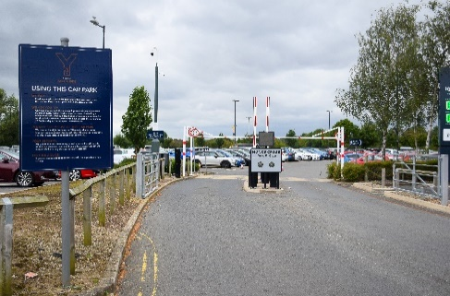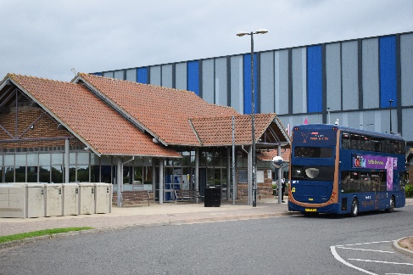

*Left: View of the car park*

*Centre: View of the bus stop*

*Right: Walking route from the car park/bus stop to the stadium main entrance, follow the red arrow past the Leisure Centre reception to access turnstiles 7-9 (red circle)*

**Makaton on Big Screens**

Thanks to the support of some amazing local people, we have some [Makaton](https://en.wikipedia.org/wiki/Makaton) videos to display on the big screens both inside and outside of the stadium which will show:

* ‘Welcome to The LNER Community Stadium’
* ‘Thank you for your support’
* ‘Goal!’
* ‘Come on City!’

Look out for them on the big screens and feel free to join in!

**Audio Devices, Ear Defenders and Sensory Packs**

York City FC and [The Wilf Ward Family Trust](https://wilfward.org.uk/) continued their excellent working relationship in the 2024/25 season by expanding their match day accessibility provision. The aim is to create a welcoming and supportive environment for all fans, ensuring that every individual can enjoy the excitement of sports and feel fully included in the community.

*Audio Devices*  
Blind or partially sighted supporters can loan a matchbox-size audio device to hear real-time audio commentary of the match from BBC Radio York (using a radio streaming service can have up to a seven second delay). Please bring your own headphones with an aux input cable to use.

*Ear Defenders*

We are able to provide complimentary ear defenders, which are yours to keep, upon request to help individuals who may experience sensory overload during the game.

*Sensory Packs\**

We also have ten x sensory packs which are available to loan on a match-by-match basis; please note that we can only offer one pack per family/group per match to make sure as many can access these as possible.

*Sensory packs and individual items (fidget spinners and stress balls) will be available to purchase, so they are yours to keep, [in our Club Shop here](https://yorkcityfootballclub.co.uk/product/sensory-packs/).

*Left: Audio device, which receive real-time match commentary from BBC Radio York, can be loaned by completing* [*this form*](https://forms.office.com/e/CMGnT4c5SB) *(please bring your own headphones with an aux input cable to use).*

*Centre: Sensory packs, which will soon be available to purchase from our Club Shop or loan on a match by match basis by completing* [*this form*](https://forms.office.com/e/CMGnT4c5SB)*.*

*Right: Ear defenders, which are included in sensory packs but can be obtained individually free of charge upon completion of* [*this form*](https://forms.office.com/e/CMGnT4c5SB) *and are yours to keep.*

Supporters who wish to access any of these resources are requested to complete [this short form](https://forms.office.com/e/CMGnT4c5SB) once they have secured their tickets so that we can prepare the appropriate number of items to distribute on the day. Anyone who does not complete the form but would like to receive a resource may not be able to so please complete the form in advance to avoid disappointment.  
  
*Collection and Return*  
On the day, head to Turnstiles 7-9 (closest to the swimming pool entrance of the Leisure Centre) to collect your ear defenders and/or sensory packs from our [YCFC Volunteers](https://yorkcityfootballclub.co.uk/volunteers/) team.  
  
After the match, you are kindly requested to return your sensory pack(s) to the club office, located inside the Leisure Centre (opposite the lifts).

Firstly, [please complete this form](https://forms.office.com/e/CMGnT4c5SB) to let us know that you’d like to collect a set at the match.

At turnstiles 7-9, you’ll meet the lovely **Doreen** (below), part of our match day volunteers team, [YCFC Volunteers](https://yorkcityfootballclub.co.uk/volunteers/), who will have your resource(s). Providing you’ve [completed the form](https://forms.office.com/e/CMGnT4c5SB), just give your name(s) and pick yours up.

*Left: Doreen (left) - see them to get your resource(s) before you enter the stadium*

*Right: Once inside, toilets are in front of you then travel down this passageway to find your seats.*

**Stadium Entry**

All entries to the stadium require a match ticket, which must be scanned before entry. There are automated turnstiles with built-in ticket scanners to use but for those uncomfortable with small spaces, please speak to any of the stewards on duty who will grant you access through a large gate next to the turnstiles, rather than the regular turnstile, upon presentation of your match tickets.

*Left: Turnstiles 1-6, serving the South and East Stand (blocks F-I)*

*Centre: View of the West Stand entry point*

*Right: Turnstiles 7-9, entry point for the East Stand (blocks A-D) including the Quiet Zone; the gate you can go through is on the right of the picture*

*Wheelchair and Mobility Scooter Users and Supporters with Limited Mobility*

Enter the stadium via the Hospitality Entrance where you can access the lifts to take you to the top of the East Stand. Once the doors open, our match day volunteers will signpost you through the Jorvik Lounge and out to the gantry through the accessible route. From here, you can access the wheelchair and mobility scooter user spaces as well as any other seats in the stand, which may be particularly helpful to those seated towards the top of the stand. Wheelchair and mobility scooter users are welcome to enter and exit via the Jorvik Lounge to access concessions stalls and toilets and return outside to enjoy the match.

*Top Left: View of the Hospitality Entrance*

*Top Right: View of the East Stand lifts, take one of these to Floor 2*

*Bottom Left: View from exiting the East Stand lifts; see our* [*YCFC Volunteers*](https://yorkcityfootballclub.co.uk/volunteers/) *to be guided to your space via the accessible route*

*Bottom Right: View of a West Stand lift*

**Toilets and Changing Facilities**

There are male, female, and accessible toilets in every stand within the stadium and Hospitality. For those requiring a Changing Places Toilet, this can be found at the Leisure Centre reception.

All toilets within the stadium also feature baby changing facilities. All accessible toilets inside the stadium are now stoma-friendly to support those with additional needs.

*Wheelchair and Mobility Scooter Users*

Toilets are located just inside the swimming pool entrance to the stadium, with more on Floor 2 which can be accessed via the Hospitality lounges once your match ticket(s) has been scanned.

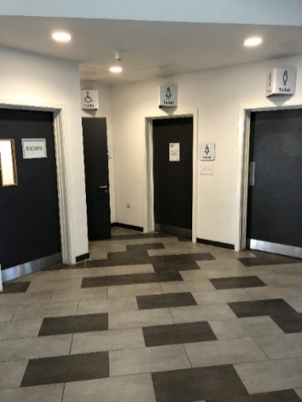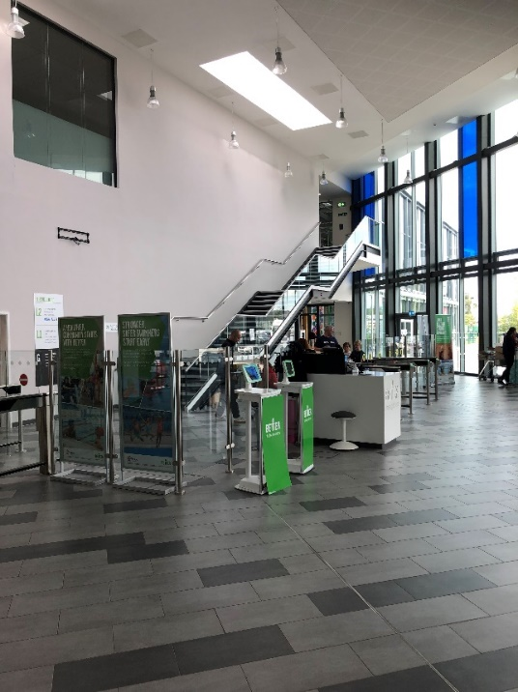

*Left: View of the toilets and Quiet Room, just inside the Leisure Centre entrance*

*Right: Leisure Centre reception*

**Safe Exit and Quiet Room**

If for any reason you need to leave the stadium, go back the way you came in and stewards will help guide you outside to a safe, quiet space.

A quiet room (see photo above) is accessible on the day for anyone who needs a private space; please just speak to the Leisure Centre reception for access.

**Leaving the Stadium**

Whenever you would like to leave the stadium, please do so via the same route as when you came in. Please speak to club volunteers or any match day stewards if you’re not sure where to go.

*Wheelchair and Mobility Scooter Users*

In cases of emergency, all wheelchair or mobility scooter users are advised to remain in place so that they can be guided out safely. Evac Chairs are stored at every stand for use in emergencies.

**Stadium Familiarisation Sessions (Non-Match Days)**

York City FC is proud to offer [stadium familiarisation sessions](https://forms.office.com/e/hLBdWCVcNk) to welcome and support individuals of all abilities and conditions, with a focus on making everyone feel included in our community. These free sessions are designed for supporters who, for various reasons, may have hesitated to visit the LNER Community Stadium in the past. We are committed to ensuring that everyone has the opportunity to enjoy the excitement of sports in a welcoming and supportive environment.

These sessions can be arranged at a time and date to suit you, subject to stadium and staff availability. To ensure we are well-prepared for the sessions and can make any necessary accommodations, [please complete this form](https://forms.office.com/e/hLBdWCVcNk) and we will be in touch to arrange your session. It will help us understand how many people to expect and allow us to address any specific considerations to make your visit as pleasant as possible.

**Further Information**  
To view the club’s inclusive match day guidance document for supporters, please visit [our Accessibility page](https://yorkcityfootballclub.co.uk/accessibility/).  
  
To discuss any of the initiatives in this guide further, please contact:

**Steve Dorey | Development Officer**

**York City FC**

LNER Community Stadium | Kathryn Avenue | York | YO32 9AF

**Phone:** 01904 624447

**E-Mail:** [steve.dorey@yorkcityfootballclub.co.uk](mailto:steve.dorey@yorkcityfootballclub.co.uk)

**Website:** [www.yorkcityfootballclub.co.uk](http://www.yorkcityfootballclub.co.uk/)

](https://www.yorkcityfootballclub.co.uk/)